ONE TAG 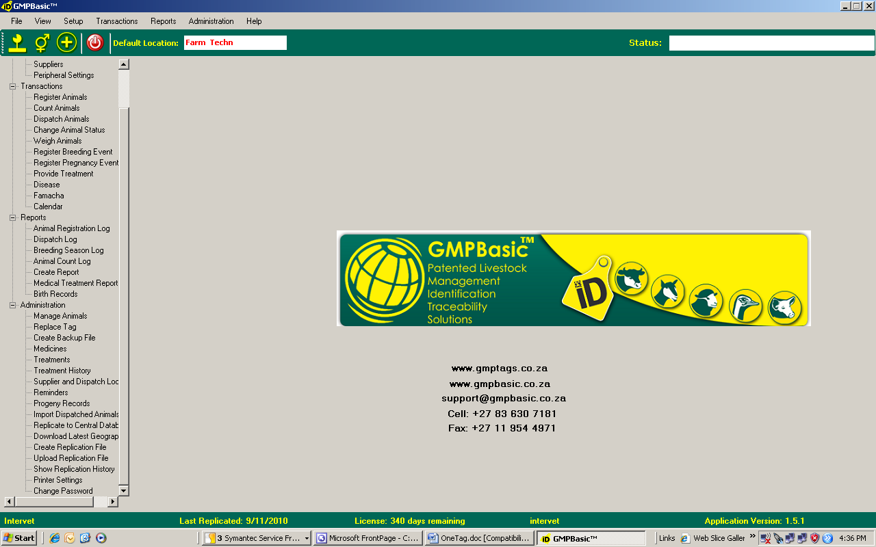 ONE SYSTEM
(Patented Central database system )

Tag animals & weigh Product administration and recording


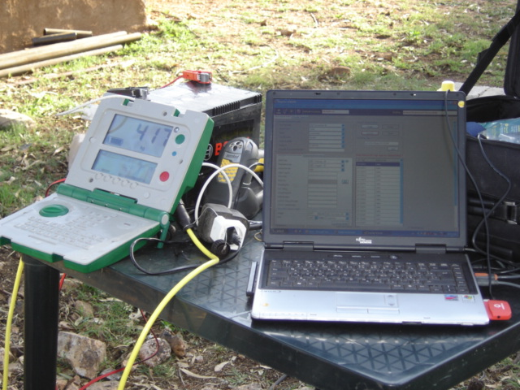

Manual Data capture Traceable record keeping
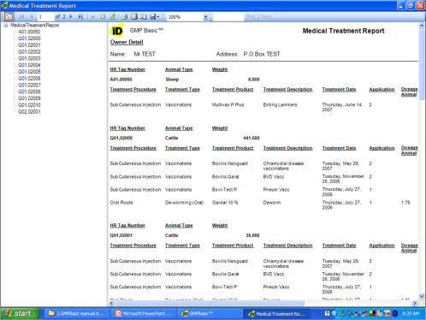
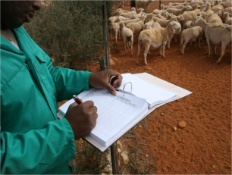

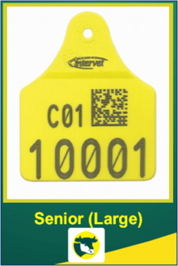

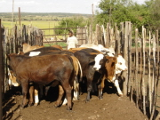
Cattle herded to a crush

Central database verification

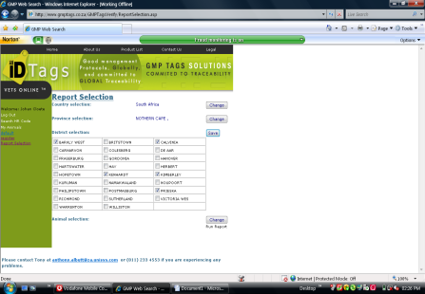

Cost effective
National Livestock
Solution

ID & Management Ostriches are easily tagged Follow through to retail
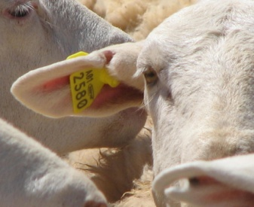
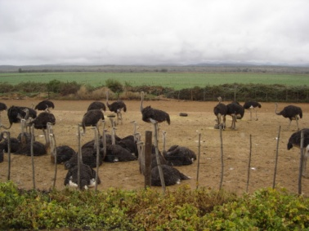
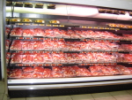

Solution 3.5% L.A. : Reg no: G3689 Act 36/1947 – Bovilis S : Reg no. G 3763 36/1947 – Avotan Pour-onReg no. G3745 Act 36/1947
GMPTAGS Contacts: Cell – 083 630 7181 e-mail: support@gmpbasic.co.za

